Contents
1 Introduction 3
1.1 Purpose and Scope 3
2 Design Overview 3
3 Detailed Design 5
3.1 Production Code 5
3.1.1 Enum TParameterType 5
3.1.2 Struct TParameterDetails 5
3.1.3 Struct TClientMessageSchema 5
3.1.4 Struct TClientMessageServerData 6
3.1.5 Class CClientMessage 6
3.1.6 Class CMessageParameterBase 8
3.1.7 Class CIntParameter 9
3.1.8 Class CDes8ReadParameter 9
3.1.9 Class CDes8Parameter 9
3.1.10 Class CDes16ReadParameter 9
3.1.11 Class CDes16Parameter 10
3.1.12 Class CPtrParameter 10
3.1.13 Class CPCkgParameter 10
4 Usage 11
5 Further Information 13
5.1 References 13
5.2 Open Issues 13
5.3 Glossary 13
5.4 Document History 13

Introduction

Purpose and Scope
This document describes the new IPC Message sanitization design implemented in The Base Services utility Library (Bsul.dll). This new design is in response several IPC robustness defects raised against System Libraries. The investigation of these defects led to the realisation that there was a need for a generic IPC Message sanitization strategy that could be deployed across all system servers. This document describes the classes that implement the new strategy.
The target audience of this document is the TA and engineers within System Libraries, Tools and Test Engineering.

Design Overview
Currently in most system servers within System Libraries, IPC messages are not systematically checked for validity. This has several impacts. Firstly system servers are vulnerable to IPC attack if they do not sanitize incoming messages. In some cases, as in the case that led to INC113760 being raised, this can result in the system server panicking and potentially forcing a reboot of the phone. Secondly if sanitization is done, it tends to be done in an ad hoc fashion, with ASSERTS scattered throughout the code. This makes error tracing difficult and can itself lead to errors.
The solution to this issue was to introduce a new IPC sanitization strategy that localised message sanitization, error handling and logging. In order to allow this strategy to be rolled out easily across several system servers, a data-driven design was implemented.

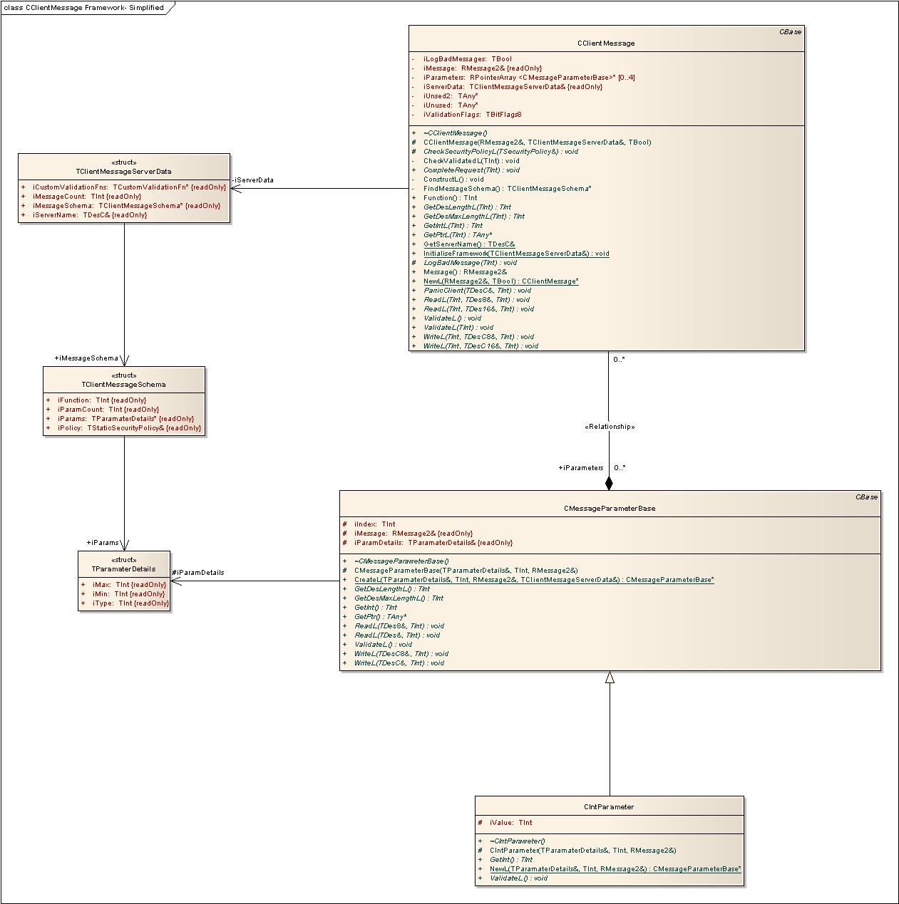
- CClientMessage and Associated Classes ( Only 1 CMessageParameterBase derived class is shown here for clarity see Ref 1 for full model.)

Detailed Design

Production Code

Enum TParameterType
This enumeration lists the supported parameter types. These are:
- EParamNull – This is a placeholder for messages which have no arguments.
- EParamInt – This is a Tint parameter type
- EParamDes8Read – This is a read only 8 bit descriptor type. This means that the server may only read from this descriptor.
- EParamDes8 – This is a read\write 8 bit descriptor type. This means that the server may read from and write to this descriptor.
- EParamPckg – This is a TPckg<> parameter type. This means that the server may read from and write to this descriptor.
- EParamDes16Read – This is a read only 16 bit descriptor type. This means that the server may only read from this descriptor.
- EParamDes16 – This is a read\write 16 bit descriptor type. This means that the server may read from and write to this descriptor.
- EParamPtr – This is a Ptr parameter type. Although the use of this is discouraged it is maintained for compatibility.

Struct TParameterDetails
This structure is used to store data for a single message parameter. The data stored is defined as follows:
- iType – An integer value indicating the expected type of this message parameter. The lower 16 bits represent a TParameterType enumeration value. If the type is EParamPckg the upper 16 bits are used to represent the custom parameter type.
- iMin – Minimum accepted value for this parameter. (The exact meaning of this is dependant on parameter type and will be clarified later in this document).
- iMax – Maximum accepted value for this parameter. (The exact meaning of this is dependant on parameter type and will be clarified later in this document).

Struct TClientMessageSchema
This structure is used to store the schema for a single client message. The data stored is defined as follows:
- iFunction – The IPC message number represented by this object
- iPolicy – The Security Policy to use when checking client requests for this message
- iParamCount – The number of message arguments defined for this message
- iParameters – An array of TParameterDetails structures defining the expected behaviour of each parameter of this message.

Struct TClientMessageServerData
This structure is used to store the initialisation data for a given server. This data structure is passed in to the framework on initialisation by every server that uses it.
- iCustomValidationFunctions – An array of TCustomValidation functions which are used to validate EPckgParam parameter types
- iMessageCount – The number of messages defined for this server
- iParamCount – The number of message arguments defined for this message
- iMessageSchema – An array of TClientMessageSchema structures defining schema for each message
- iServerName – The name of the server owning this data.

Class CClientMessage
This class is used by a server to sanitise incoming messages. The class provides a wrapper around an RMessage2 object and provides a method for validation of the message against the constraints defined in the message schema. This class also provides methods for safely accessing the message arguments, and for error handling and logging of bad messages.
As the class is implemented in a Dll there are special considerations to be made as each server will have its own message schema which needs to be maintained by the framework. This is achieved by using TLS. Before it uses the framework, the server must initialise it by passing a TClientMessageServerData structure in to the initialisation function.
- InitialiseFramework(TClientMessageServerData& aServerData)
The framework stores this structure in TLS and accesses it as necessary when invoked by the server.

The class is instantiated via the following static factory function:
- static CClientMessage* NewL(const RMessage2& aMessage, TBool aLogBadMessages)
On construction a set of up to 4 CMessageParameterBase objects are instantiated using the TParameterDetails structs in the message schema and these are objects stored in an RPointerArray. The objects represent the individual message arguments and are used to validate each argument against the constraints defined in the message schema. Access to the information in the message is handled via these objects.

The class provides two methods for validating message parameters, and stores the results of the parameter validation internally. These validation functions are:
- virtual void ValidateL()
- virtual void ValidateL(TInt aParam)

The class provides a method to obtain the message number and a method to obtain a reference to the underlying RMessage2 object. These methods are:
- TInt Function()
- const RMessage2& Message()

The class provides the following methods to access the data:
- virtual TInt GetIntL(TInt aParam)
- virtual const TAny* GetPtrL(TInt aParam)
- virtual Tint GetDesLengthL(TInt aParam)
- virtual Tint GetDesMaxLengthL(TInt aParam)
- virtual void ReadL(TInt aParam, TDes8& aDes, TInt aOffset = 0)
- virtual void ReadL(TInt aParam, TDes16& aDes, TInt aOffset = 0)
- virtual void WriteL(TInt aParam, const TDesC8& aDes, TInt aOffset = 0)
- virtual void WriteL(TInt aParam, const TDesC16& aDes, TInt aOffset = 0)

All of these access methods fail if the parameter has not been validated before they are called.

The class provides a method to complete the client request:
- virtual void CompleteRequestL(TInt aError)

The class also provides a method to Panic the client:
- virtual void PanicClient(const TDesC& aServer, TInt aPanic)

The class stores a reference to the RMessage represented by this object and an RPointerArray of CMessageParameterBase objects. It also keeps a TBitFlags8 object indicating which of the parameters have been validated.

Class CMessageParameterBase
This is the abstract base class for all message parameter classes. The class defines one pure virtual function, ValidateL, which all derived classes must implement. This function defines how a message argument is validated against the parameter constraints defined in the message schema. The class defines access functions for all 6 currently supported parameter types. These functions are
- virtual TInt GetInt()
- virtual TAny* GetPtr()
- virtual TInt GetDesLengthL()
- virtual TInt GetDesMaxLengthL()
- virtual const TDesC8& GetDes8L()
- virtual const TDesC& GetDes16L()
- virtual void WriteL(const TDesC8& aDes, Tint aOffset)
- virtual void WriteL(const TDesC& aDes, Tint aOffset)
- virtual void ReadL(const TDes8& aDes, Tint aOffset)
- virtual void ReadL(const TDes& aDes, Tint aOffset)

In the base class all of these functions are defined to Panic with reason ECMWrongParameterType. The classes derived from CMessageParameterBase all define the appropriate access methods for that parameter type. Defining the functions in the base class provides an extra degree of type checking. As CClientMessage contains an array of CMessageParameterBase objects, if the base class pointer is used to call a method not supported by the parameter type a Panic will occur.
The base class stores a reference to the RMessage2 object that the parameters relate to and stores the index of the parameter within the message.
An instance of a CMessageParameterBase derived class is instantiated by calling the following function:
- static CMessageParameterBase* CreateL(const TParamaterDetails& aParam,
TInt aParamIndex,
const RMessage2& aMessage)

This function determines the type of the parameter object to be created by masking the lower 16 bits of the iType field of aParam. The type is used as an index in a lookup table to instantiate a CMessageParameterBase derived object by calling the appropriate factory function. The upper 16 bits of the iType field are used as an index in the array of custom validation function pointers supplied on initialisation. The appropriate custom validation function pointer is passed to the factory function for the CMessageParameterBase derived class. If no custom validation is required, then the upper 16 bits of iType must be set to 0x0000.

Class CIntParameter
This class implements the ValidateL method for a TInt parameter. The TInt value is read from the client’s message and stored locally. If the supplied custom validation function pointer is not Null, Validate L calls that function. Otherwise ValidateL checks that the stored value falls between the bounds of iMin and iMax defined in the message schema for this parameter.
This class also defines the following access function:
- virtual TInt GetInt()

Class CDes8ReadParameter
This class implements the ValidateL method for a read only TDes8 parameter. If the supplied custom validation function pointer is not Null, Validate L calls that function. Otherwise ValidateL checks that the length of the descriptor argument in the client’s process is between iMin and iMax defined in the message schema for this parameter.
As the descriptor is read only, ValidateL immediately reads and stores the descriptor from the clients process, potentially saving the time for a further context switch.
This class also defines the following access function:
- virtual TInt GetDesLengthL()
- virtual const TDesC8& GetDes8L()
- virtual void ReadL(const TDes8& aDes, Tint aOffset)

Class CDes8Parameter
This class implements the ValidateL method for a read\write TDes8 parameter. If the supplied custom validation function pointer is not Null, Validate L calls that function. Otherwise ValidateL checks that the MaxLength of the descriptor in the client’s process is not less than iMin and that the length of the descriptor does not exceed iMax defined in the message schema for this parameter.
This class also defines the following access function:
- virtual TInt GetDesLengthL()
- virtual TInt GetDesMaxLengthL()
- virtual void ReadL(const TDes8& aDes, Tint aOffset)
- virtual void WriteL(const TDesC8& aDes, Tint aOffset)

Class CDes16ReadParameter
This class implements the ValidateL method for a read only TDes8 parameter. If the supplied custom validation function pointer is not Null, Validate L calls that function. Othewise ValidateL checks that the length of the descriptor in the process is between iMin and iMax defined in the message schema for this parameter.
As the descriptor is read only, ValidateL immediately reads and stores the descriptor from the clients process, potentially saving the time for a further context switch.
This class also defines the following access function:
- virtual TInt GetDesLengthL()
- virtual const TDesC& GetDes16L()
- virtual void ReadL(const TDes& aDes, Tint aOffset)

Class CDes16Parameter
This class implements the ValidateL method for a read\write TDes8 parameter. If the supplied custom validation function pointer is not Null, Validate L calls that function. Otherwise ValidateL checks that the MaxLength of the descriptor in the client’s process is not less than iMin and that the length of the descriptor does not exceed iMax defined in the message schema for this parameter.
This class also defines the following access function:
- virtual TInt GetDesLengthL()
- virtual TInt GetDesMaxLengthL()
- virtual void ReadL(const TDes& aDes, Tint aOffset)
- virtual void WriteL(const TDesC& aDes, Tint aOffset)

Class CPtrParameter

This class implements the ValidateL method for a Ptr parameter. If the supplied custom validation function pointer is not Null, Validate L calls that function. Othewise ValidateL reads the TAny* from the clients message and checks that it is not null. The use of this parameter type is discouraged, but it is maintained for compatibility.

Class CPCkgParameter

This class implements the ValidateL method for a Pckg parameter and is derived from CDes8Parameter. If the supplied custom validation function pointer is not Null, Validate L calls that function. Otherwise ValidateL checks that the length of the descriptor in the process is between iMin and iMax defined in the message schema for this parameter.
The class does not explicitly define any further access functions, but as it is derived from CDes8Parameter, the following functions are available via the base class:
- virtual TInt GetDesLengthL()
- virtual TInt GetDesMaxLengthL()
- virtual void ReadL(const TDes8& aDes, Tint aOffset)
- virtual void WriteL(const TDesC8& aDes, Tint aOffset)

Usage
To use the ClientMessage framework a server must link to Bsul.dll and include Epoc32/include/bsul/bsul.h. The server must also define a message schema for the framework to validate messages against. This should be done in a .cpp file which is part of the server project.
Below is an example schema that defines 4 messages, including 2 that define custom validation functions. The data is passed to the framework via a const TClientMessageServerData structure.
#include <bsul/bsul.h>
using namespace BSUL;
//This enum defines the custom parameter types used to validate //TPckg<TMyStruct> and TPckg<TMyStruct1> parameters.
enum TCustomParamType
{
EParamCustom1 = (0x000 | EParamPckg),
EParamCustom2 = (0x100 | EParamPckg)
};

//Defines the schema for each message
const TParamaterDetails KMessage0Params[2] = {{EParamInt,-10,100},
{EParamInt,0,200}};

const TParamaterDetails KMessage1Params[2] = {{EParamDes8Read,64,64},
{EParamInt,0,64}}};

//Parameter is TPckg<TMyStruct>
const TParamaterDetails KMessage2Params[1] = {{EParamCustom1,sizeof(TMyStruct),sizeof(TMyStruct)}};

//Parameter is TPckg<TMyStruct1>
const TParamaterDetails KMessage3Params[1] = {{EParamCustom2,sizeof(TMyStruct1),sizeof(TMyStruct1)}};

//Define the security policies for each message
_LIT_SECURITY_POLICY_PASS(KDefaultPolicy);
_LIT_SECURITY_POLICY_C2(KMsg2Policy, ECapabilityReadUserData, ECapabilityWriteUserData);

//This is the array of TClientMessageSchema structs that define the messages that will be accepted by the server.
const TClientMessageSchema KClientMessages[] =
{
{EMessage0,
KDefaultPolicy,
sizeof(KMessage0Params)/sizeof(TParamaterDetails),KMessage0Params},

{EMessage1,
KDefaultPolicy,
sizeof(KMessage1Params)/sizeof(TParamaterDetails),KMessage1Params},

{EMessage2,
KMsg2Policy,
sizeof(KMessage2Params)/sizeof(TParamaterDetails),KMessage2Params},

{EMessage3,
KDefaultPolicy,
sizeof(KMessage3Params)/sizeof(TParamaterDetails),KMessage3Params}
};
//These are the custom validation functions that are used to validate //TPckg<TMyStruct1> and TPckg<TMyStruct1> parameters
static void CustomValidationFn1L(CMessageParameterBase* aParameter);
static void CustomValidationFn2L(CMessageParameterBase* aParameter);

//This is the array of custom validation functions. The index of the function //in the array should match the upper 16 bits of the value defined in //TCustomParamType enum for that parameter type.
const TCustomValidationFn KCustomValidationFunctions[] =
{
&CustomValidationFn1L,
&CustomValidationFn2L
};

//This is the initialisation data that is passed into the ClientMessage //framework by the server. It contains everything the framework needs to //validate incoming messages
extern const TClientMessageServerData KServerData =
{
sizeof(KClientMessages)/sizeof(TClientMessageSchema), KClientMessages, KCustomValidationFunctions,
(TUint8*)"My Server"
};

Below is the definition of the functions used to validate custom parameters based on EPckgParam types. Pointers to these functions are passed in to the framework in the KServerData structure above. The custom validation functions are called by CPckgParameter::ValidateL.

//This is the implementation of the custom validation function for //TPckg<TMyStruct> parameter types.
void CustomValidationFn1L(CMessageParameterBase* aParameter)
{
TMyStruct struct;
TPckg<TMyStruct> pData(struct);

aParameter->ReadL(pData,0);

TInt err = KErrNone;

//Do custom validation on TMyStruct1 type . . .

User::LeaveIfError(err);
}

//This is the implementation of the custom validation function for //TPckg<TMyStruct1> parameter types.
void CustomValidationFn2L(CMessageParameterBase* aParameter)
{
TMyStruct1 struct;
TPckg<TMyStruct1> pData(struct);

aParameter->ReadL(pData,0);

TInt err = KErrNone;

//Do custom validation on TMyStruct1 type . . .

User::LeaveIfError(err);
}

Further Information

References
No. | Document Reference | Version | Description
1 | ClientMessage.eap | 1.0 | Client Message Framework Model

Open Issues

Glossary
Term | Definition

Document History
Date | Version | Status | Author | Description
2008-03-06 | 0.1 | Draft | Chris Beale | First draft

